**Name:** Shradha Mallikarjun Patil

**USN**: 2GI20CS144

**TERMWORK 9.1**

9.1) Read a string containing 3_4 words using Scanner class object. Split it into words and for each word check if it's palindrome by writing a function isPalindrome(String the myWord, int s, int e) which return true if its palindrome else return false. Where s is start index and e is end index of the input myWord. Print it in uppercase if it is palindrome else reverse the string and print it in lowercase.  Use appropriate string functions to implement the above problem statement.

**Program:**

import java.util.*;

public class Main

{

public static void main(String args[])

{

String str;

String words[];

Scanner in=new Scanner(System.in);

System.out.println("Enter the string:");

str=in.next();

words=str.split(" ");

for(String s: words)

{

if(isPalindrame(s,0,s.length()-1))

{

System.out.println(s.toUpperCase()+" is a palindrome");

}

else{

System.out.println(reverseString(s).toLowerCase()+" is not a palindrome");

}

}

}

public static boolean isPalindrame(String word, int s, int t)

{

if(word.charAt(s)==word.charAt(t))

{

if(s<t)

return isPalindrame(word,s+1,t-1);

else if(s==t || s==t+1)

return true;

}

return false;

}

public static String reverseString(String s)

{

String rs="";

for(int i=s.length()-1;i>=0;i--)

rs=rs+s.charAt(i);

return rs;

}

}

**OUTPUT:**

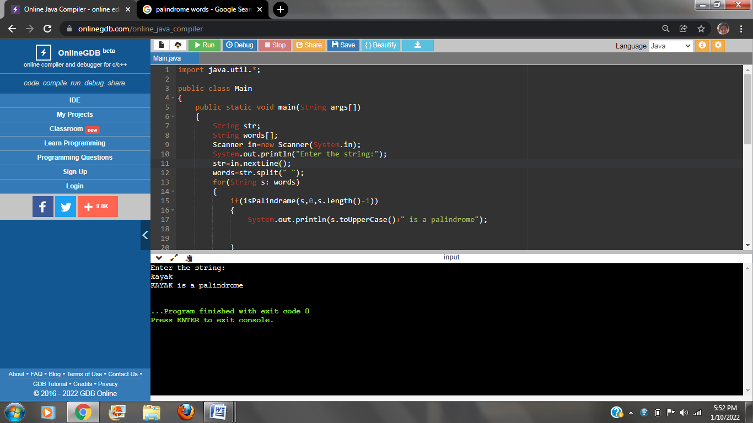



**TERMWORK 9.3**

9.3) Write a Java program that creates a simple book database (use an array of N objects). Each book is represented with a ID, title, author (First Name & last name), Genre (category – technical, Sci Fi, Fiction, Comedy etc) and a Publisher name. Define methods to perform the following tasks:

1. Given a title, returns a status to indicate whether or not the book exists in database.
2. Given a string “str”, lists the details of all the books whose title contains str.
3. Given a genre, lists publishers who have published books in that genre.
4. Given a character “c”, lists all authors who name starts with “c”.

**Program:**

**import java.util.*;**

**class Book**

**{**

**String id,title,author,genre,pubname;**

**Book()**

**{**

**Scanner in=new Scanner(System.in);**

**System.out.println("ID:");**

**id=in.nextLine();**

**System.out.println("Title:");**

**title=in.nextLine();**

**System.out.println("Author:");**

**author=in.nextLine();**

**System.out.println("genre:");**

**genre=in.nextLine();**

**System.out.println("Publisher name:");**

**pubname=in.nextLine();**

**}**

**boolean searchTitle(Book b[],String key,int n)**

**{**

**for(int i=0;i<n;i++)**

**{**

**if(b[i].title.equals(key))**

**return true;**

**}**

**return false;**

**}**

**void getpub_bygenre(Book b[],String g,int n)**

**{**

**for(int i=0;i<n;i++)**

**{**

**if(b[i].genre.equals(g))**

**{**

**System.out.println("The books published in "+g+" are "+b[i].pubname);**

**}**

**}**

**}**

**void getauthor_bychar(Book b[],char c,int n)**

**{**

**for(int i=0;i<n;i++)**

**{**

**if(b[i].author.charAt(0)==c)**

**System.out.println(b[i].author);**

**}**

**}**

**}**

**public class Main**

**{**

**public static void main(String args[])**

**{**

**int n;**

**Scanner in =new Scanner(System.in);**

**System.out.println("Enter the number of books:");**

**n=in.nextInt();**

**Book b[]=new Book[n];**

**Book b1[];**

**b1=b;**

**for(int i=0;i<n;i++)**

**{**

**System.out.println("\nBook "+(i+1));**

**b[i]=new Book();**

**}**

**String k,g;**

**System.out.println("Enter Book title for search");**

**k=in.next();**

**if(b1[0].searchTitle(b,k,n))**

**System.out.println("The book is Found");**

**else**

**System.out.println("The book is Not found");**

**System.out.println("Enter desired genre");**

**g=in.next();**

**b1[0].getpub_bygenre(b,g,n);**

**char c;**

**System.out.println("Enter a Character:");**

**c=in.next().charAt(0);**

**System.out.println("Authors whose name start with "+c+" are:");**

**b1[0].getauthor_bychar(b,c,n);**

**}**

**}**

**OUTPUT:**

